Intersection of Loci

Definition
# Source: AI Source: Provided by: [Data Path: Persons Table -> ID Column: 1, Name_En Column: Motasem Essam] -> From: [ChatGPT] on [7/25/2026]
The intersection of loci is the set of points that satisfy two or more locus conditions simultaneously.
If one locus is $L_{1}$and another locus is $L_{2}$, their intersection is
$$\boxed{L_{1}∩L_{2}}$$
A point $P$belongs to the intersection only if it satisfies every condition defining the relevant loci.
$$\boxed{P∈L_{1}∩L_{2} ⟺ P∈L_{1}\text{ and }P∈L_{2}}$$
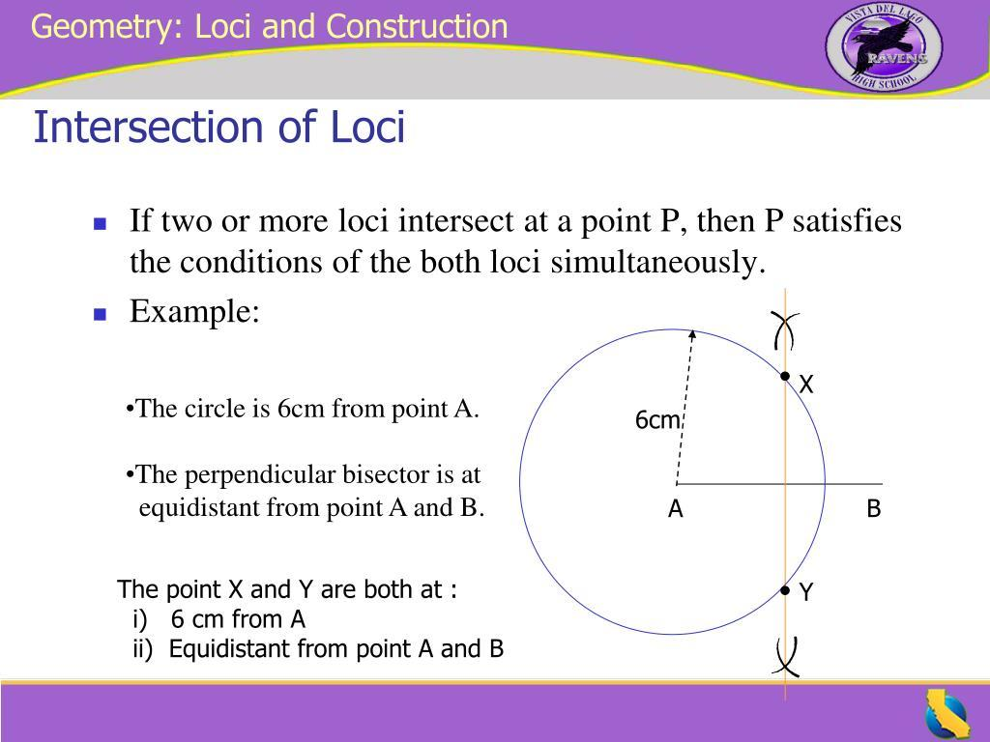
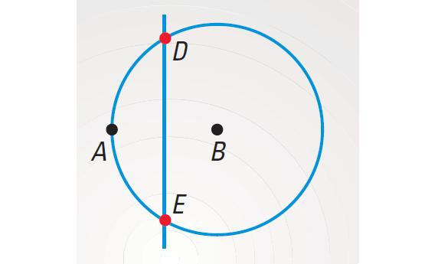
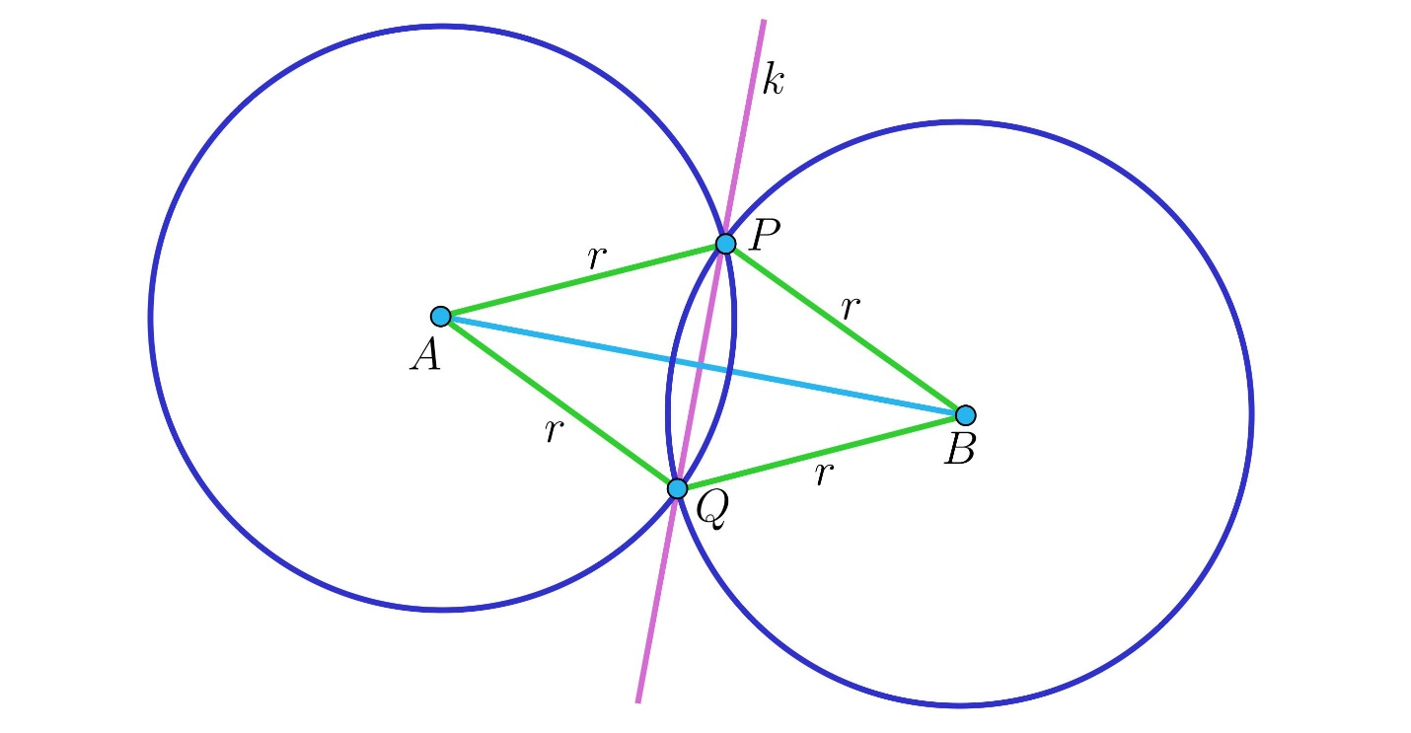
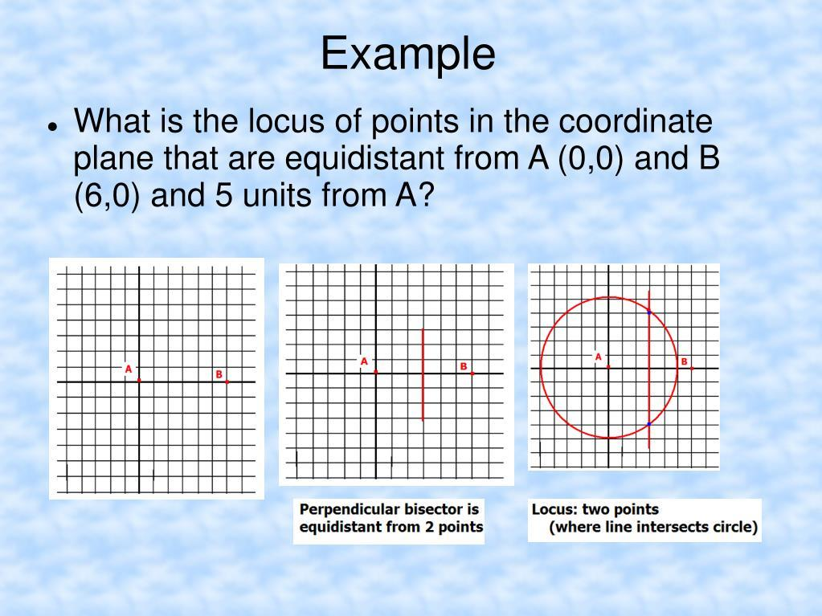

Simple Definition
# Source: AI Source: Provided by: [Data Path: Persons Table -> ID Column: 1, Name_En Column: Motasem Essam] -> From: [ChatGPT] on [7/25/2026]
Intersection of loci is the set of points common to two or more loci.
For example:
- $L_{1}$: points $2$units from $A$
- $L_{2}$: points $3$units from $B$
The required points are the intersections of the two circles.

Fundamental Concept
# Source: AI Source: Provided by: [Data Path: Persons Table -> ID Column: 1, Name_En Column: Motasem Essam] -> From: [ChatGPT] on [7/25/2026]
A locus represents a condition.
For example:
$$PA=5$$
represents a circle centered at $A$.
Another condition might be:
$$PB=4.$$
This represents another circle centered at $B$.
If we require both conditions simultaneously:
$$PA=5$$
and
$$PB=4,$$
then $P$must lie on both circles.
Therefore:
$$\boxed{\text{Two Locus Conditions}→\text{Common Points}}$$
These common points form the intersection of the loci.

Basic Set-Theoretic Interpretation
# Source: AI Source: Provided by: [Data Path: Persons Table -> ID Column: 1, Name_En Column: Motasem Essam] -> From: [ChatGPT] on [7/25/2026]
If
$$L_{1}=\left\{P:P\text{ satisfies condition 1}\right\}$$
and
$$L_{2}=\left\{P:P\text{ satisfies condition 2}\right\},$$
then
$$\boxed{L_{1}∩L_{2}=\left\{P:P\text{ satisfies both conditions}\right\}}$$
This is exactly the ordinary mathematical meaning of intersection.

Two Circles
# Source: AI Source: Provided by: [Data Path: Persons Table -> ID Column: 1, Name_En Column: Motasem Essam] -> From: [ChatGPT] on [7/25/2026]
The intersection of two circle loci can contain:
- no points,
- one point,
- two points,
- or, in the special case of coincident circles, infinitely many points.
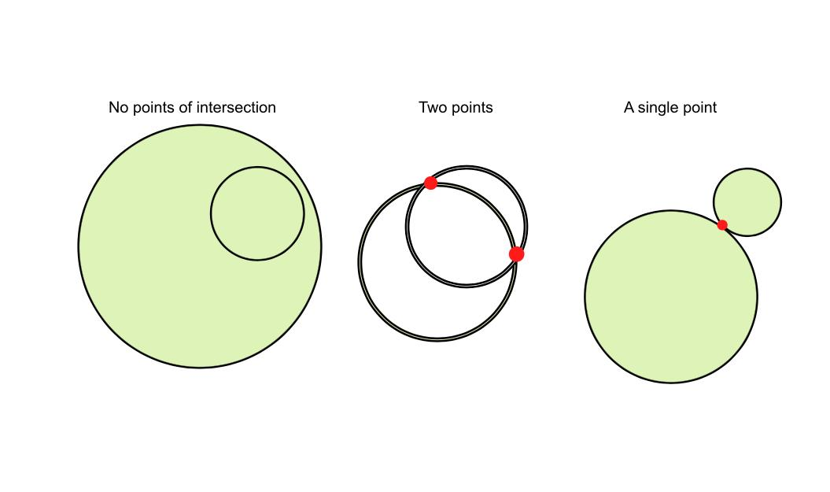
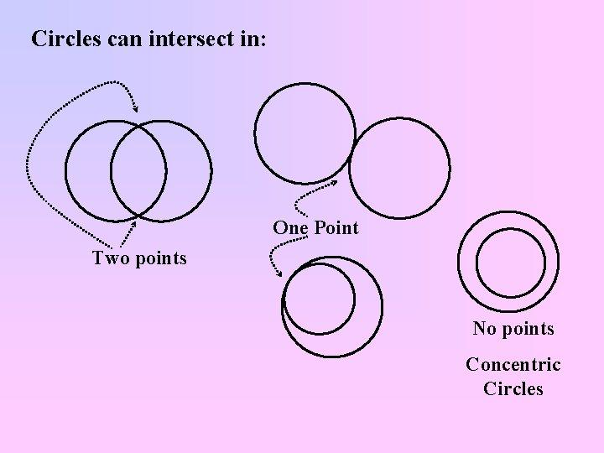
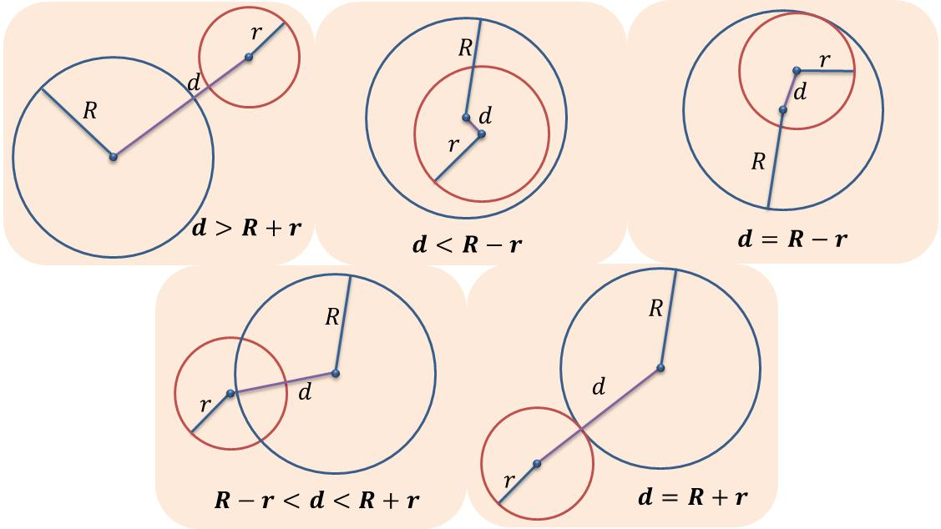
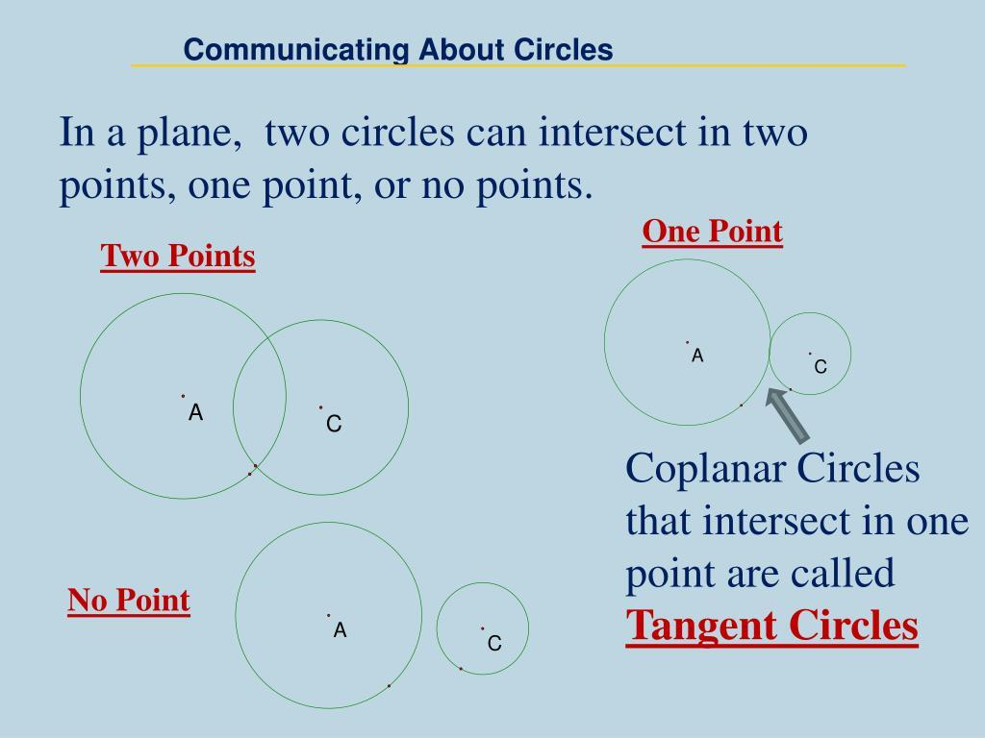
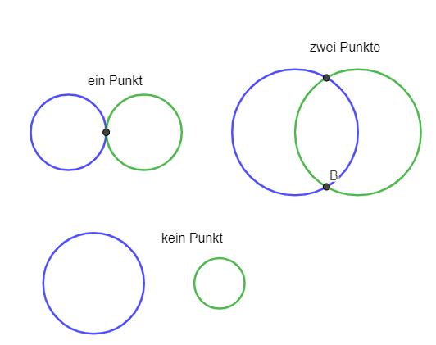
Let the circles have centers $A,B$, radii $r_{1},r_{2}$, and center distance
$$d=AB.$$
No intersection
If
$$d>r_{1}+r_{2}$$
the circles are separate.
Also, if
$$d<∣r_{1}-r_{2}∣,$$
one circle lies completely inside the other without touching.
One intersection
External tangency:
$$\boxed{d=r_{1}+r_{2}}$$
or internal tangency:
$$\boxed{d=∣r_{1}-r_{2}∣}.$$
Two intersections
$$\boxed{∣r_{1}-r_{2}∣<d<r_{1}+r_{2}}.$$
Coincident circles
If
$$A=B, r_{1}=r_{2},$$
the circles are identical, so their intersection contains infinitely many points.

Example: Two Circle Loci
# Source: AI Source: Provided by: [Data Path: Persons Table -> ID Column: 1, Name_En Column: Motasem Essam] -> From: [ChatGPT] on [7/25/2026]
Suppose:
$$PA=5$$
and
$$PB=5.$$
The first locus is:
$$L_{1}: PA=5.$$
The second is:
$$L_{2}: PB=5.$$
Therefore:
$$\boxed{P∈L_{1}∩L_{2}}$$
means $P$is at distance $5$from both $A$and $B$.
If
$$AB=6,$$
the two circles intersect at two points.
Those two points are exactly the solutions to the two locus conditions.

Line and Circle
# Source: AI Source: Provided by: [Data Path: Persons Table -> ID Column: 1, Name_En Column: Motasem Essam] -> From: [ChatGPT] on [7/25/2026]
A line can intersect a circle in:
- zero points,
- one point,
- two points.
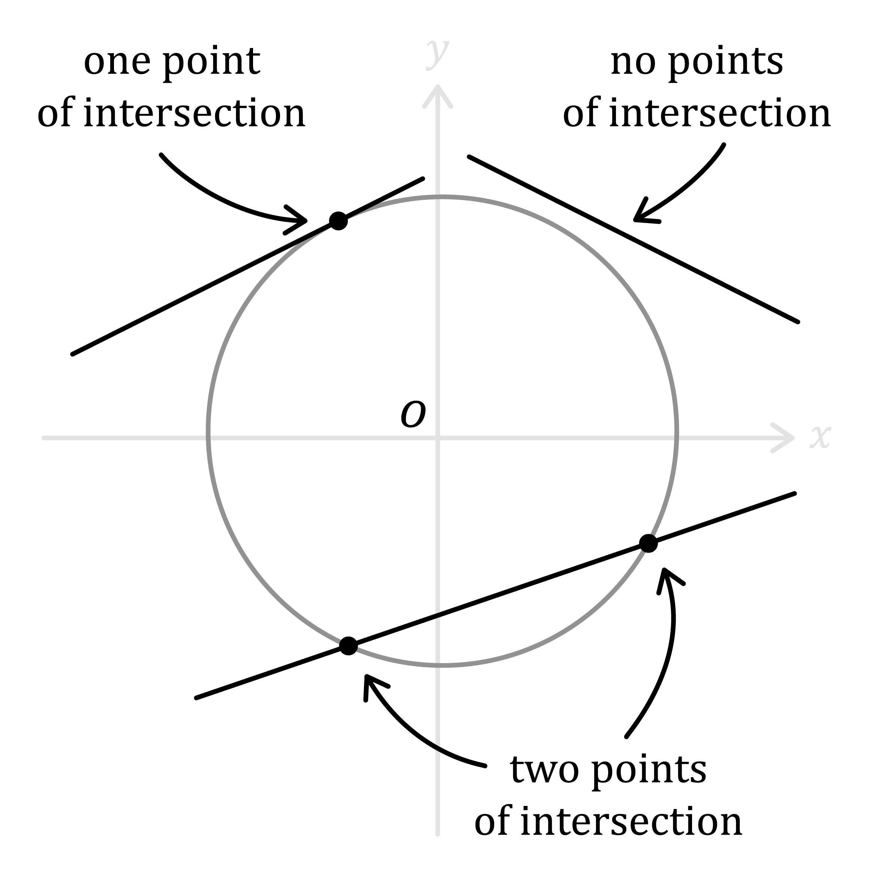
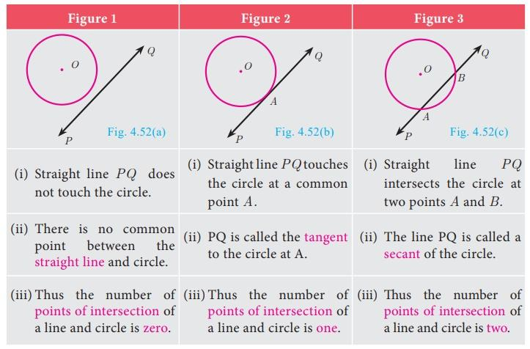
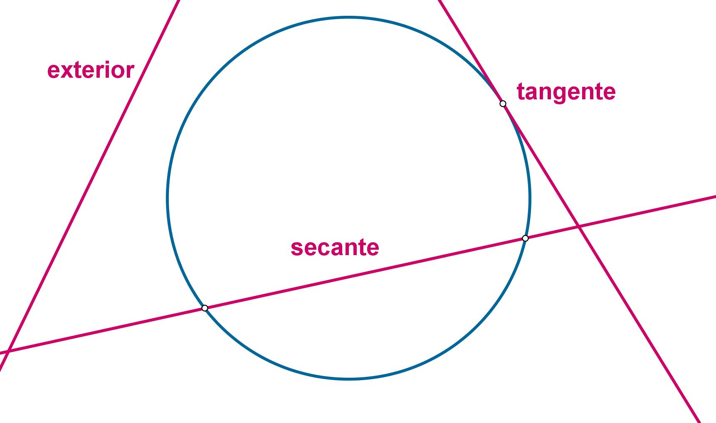
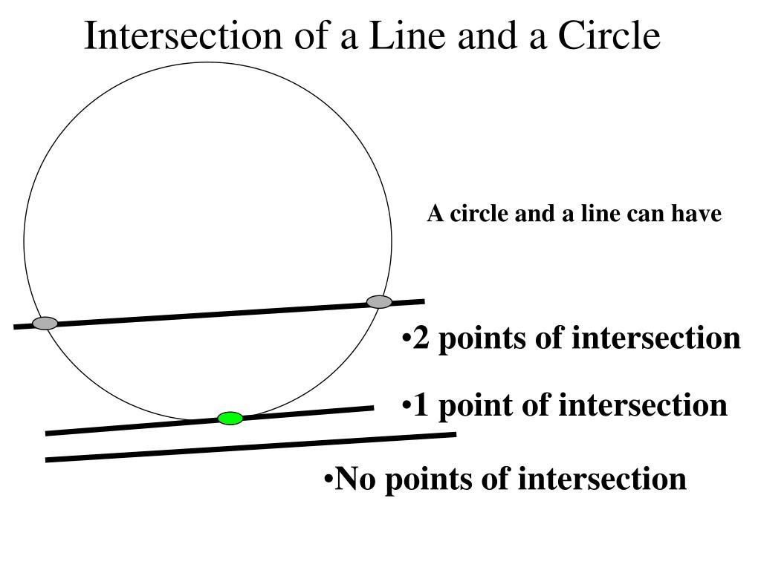
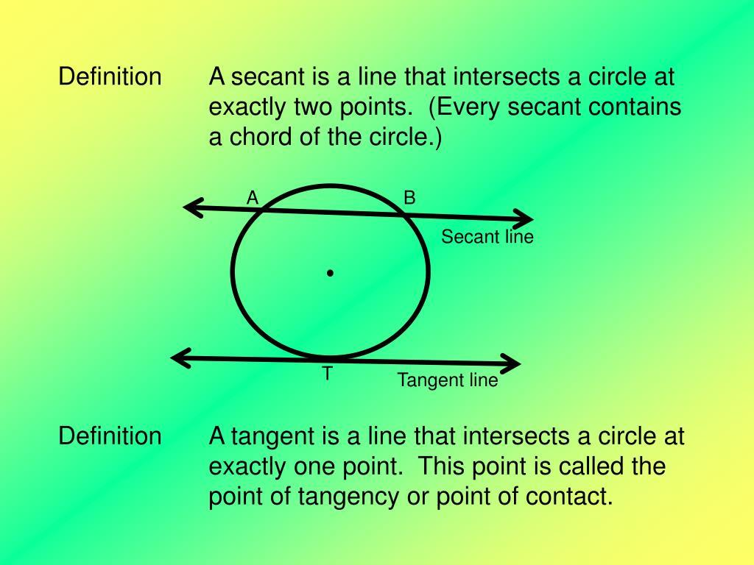
Suppose the line is a locus $L_{1}$and the circle is a locus $L_{2}$.
Then:
$$L_{1}∩L_{2}$$
contains the points satisfying both conditions.
If the perpendicular distance from the circle center $O$to the line is $d$:
No intersection
$$d>r$$
One intersection
$$d=r$$
The line is tangent.
Two intersections
$$d<r.$$
The line is a secant.

Example: Fixed Distance and Fixed Line
# Source: AI Source: Provided by: [Data Path: Persons Table -> ID Column: 1, Name_En Column: Motasem Essam] -> From: [ChatGPT] on [7/25/2026]
Suppose $P$must satisfy:
$$PA=5$$
and
$$P∈l.$$
The first condition produces a circle centered at $A$.
The second condition produces the fixed line $l$.
Therefore:
$$\boxed{P∈\text{circle}∩\text{line}}$$
The possible points are the intersections of the circle and line.
Thus there may be:
$$\boxed{0, 1,\text{ or }2\text{ solutions}}.$$

Two Perpendicular-Bisector Loci
# Source: AI Source: Provided by: [Data Path: Persons Table -> ID Column: 1, Name_En Column: Motasem Essam] -> From: [ChatGPT] on [7/25/2026]
Suppose three fixed points $A,B,C$are given.
The circumcenter $O$satisfies:
$$OA=OB$$
and
$$OA=OC.$$
Therefore $O$belongs to two perpendicular-bisector loci:
$$L_{1}=\left\{P:PA=PB\right\}$$
and
$$L_{2}=\left\{P:PA=PC\right\}.$$
Thus:
$$\boxed{O=L_{1}∩L_{2}}.$$
The intersection is the circumcenter.
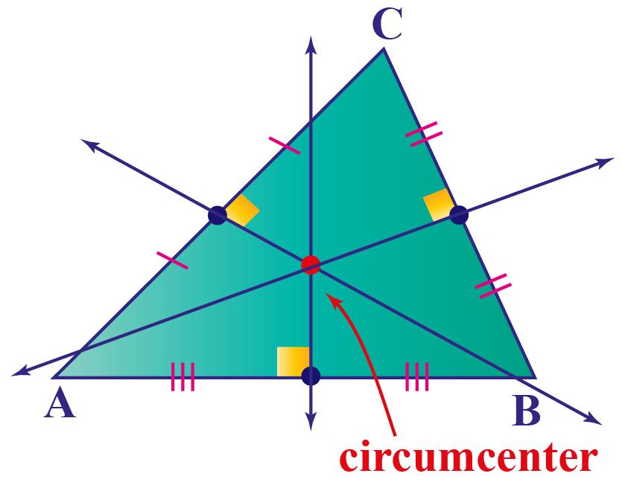
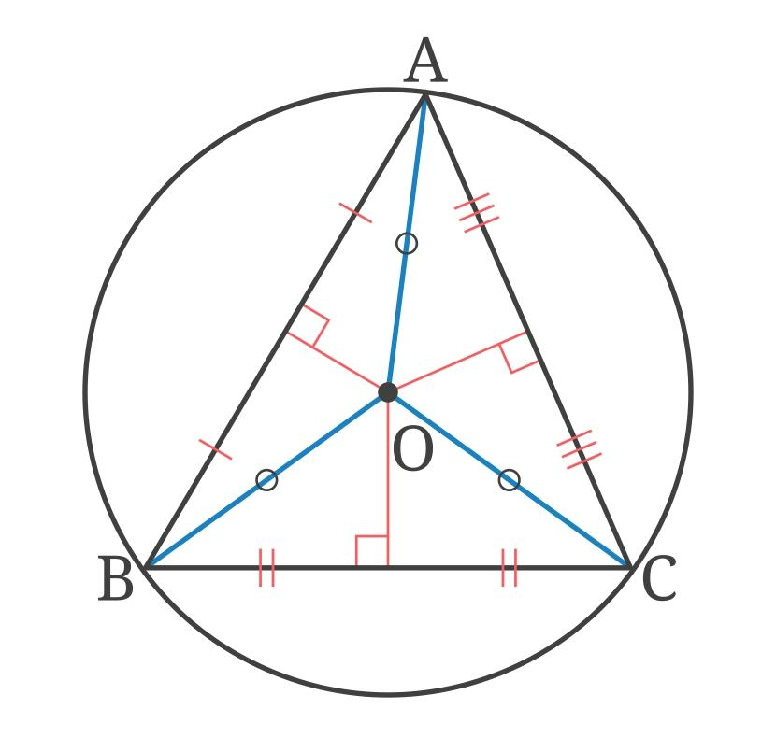
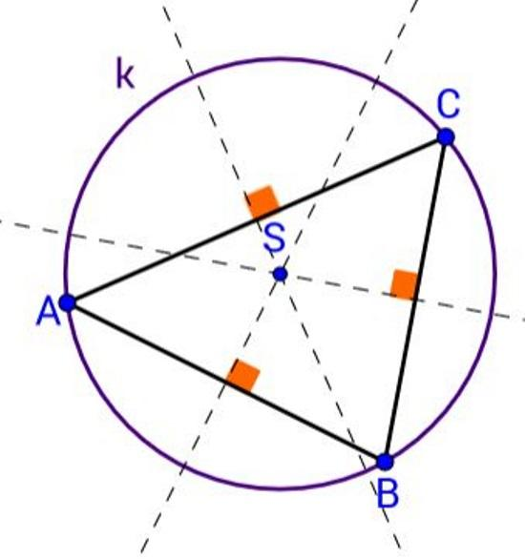
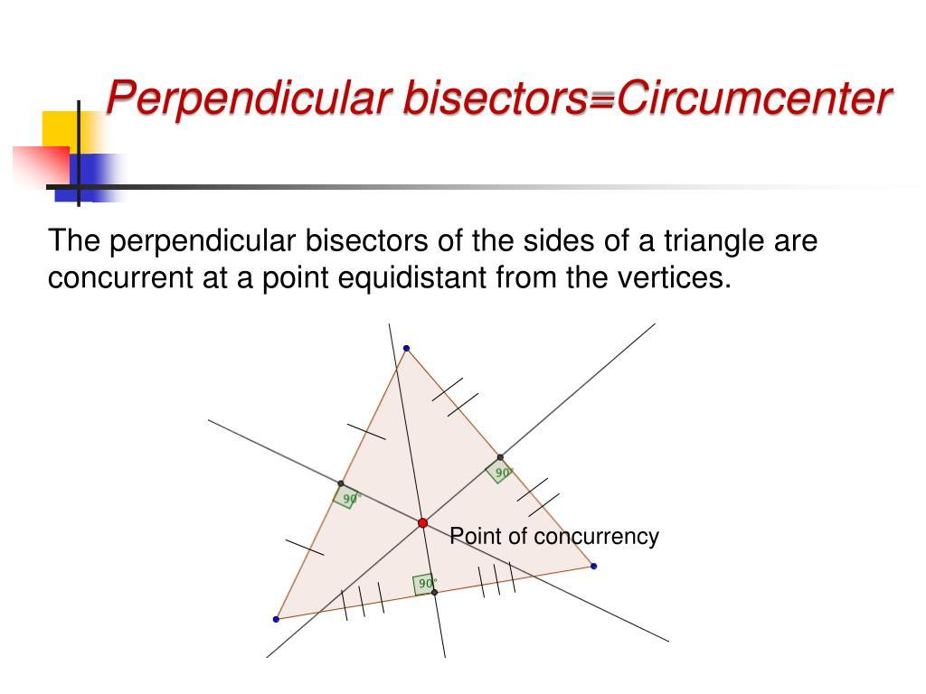
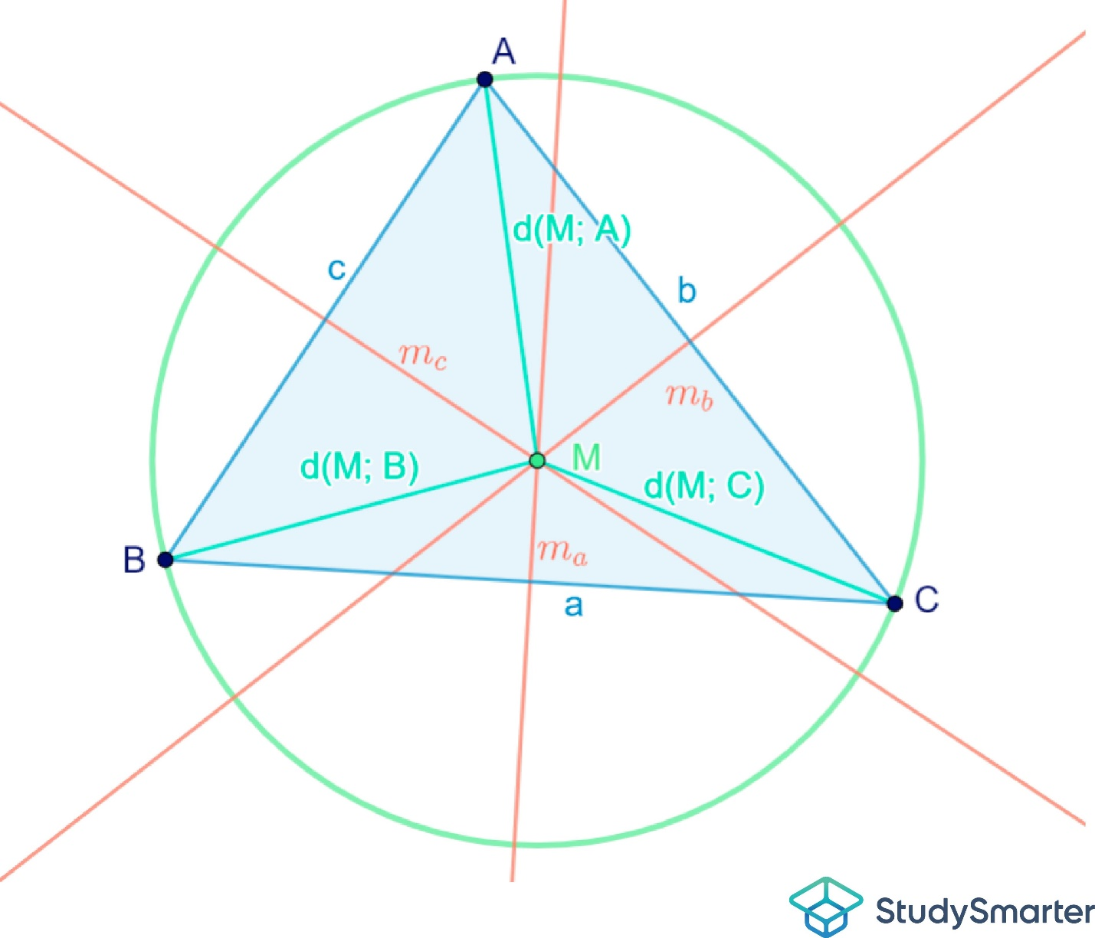
This is an important application of intersecting loci.

Two Angle-Bisector Loci
# Source: AI Source: Provided by: [Data Path: Persons Table -> ID Column: 1, Name_En Column: Motasem Essam] -> From: [ChatGPT] on [7/25/2026]
In a triangle, the incenter can also be understood as an intersection of loci.
The internal angle bisector of $∠A$is the locus of points equidistant from $AB$and $AC$.
The internal angle bisector of $∠B$is the locus of points equidistant from $BA$and $BC$.
Their intersection is the incenter $I$.
Therefore:
$$\boxed{I=\text{Angle Bisector of }A∩\text{Angle Bisector of }B}$$
and automatically $I$lies on the angle bisector of $C$.
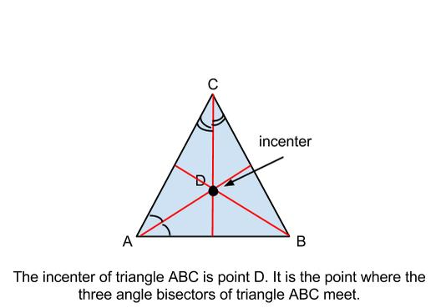
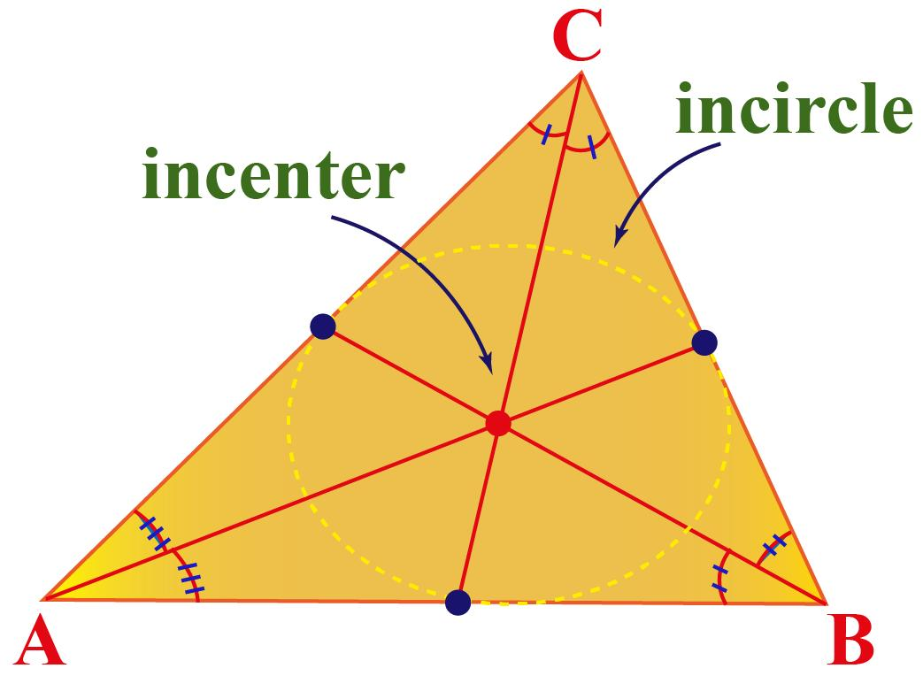
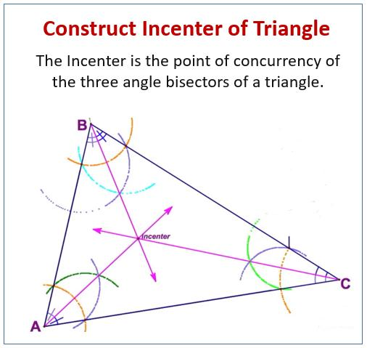
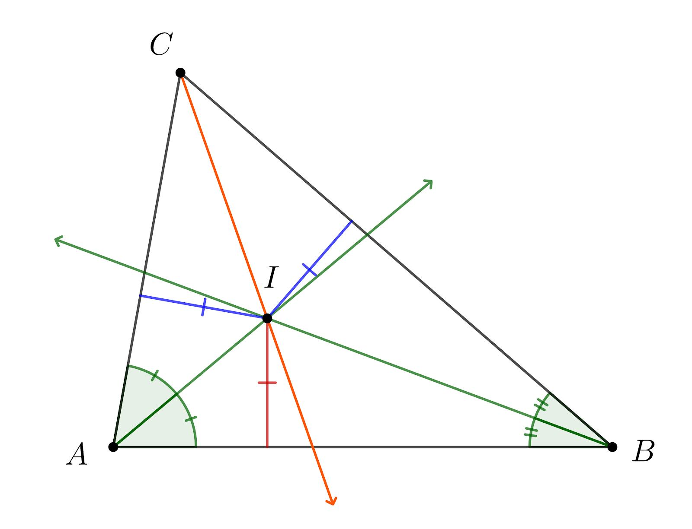
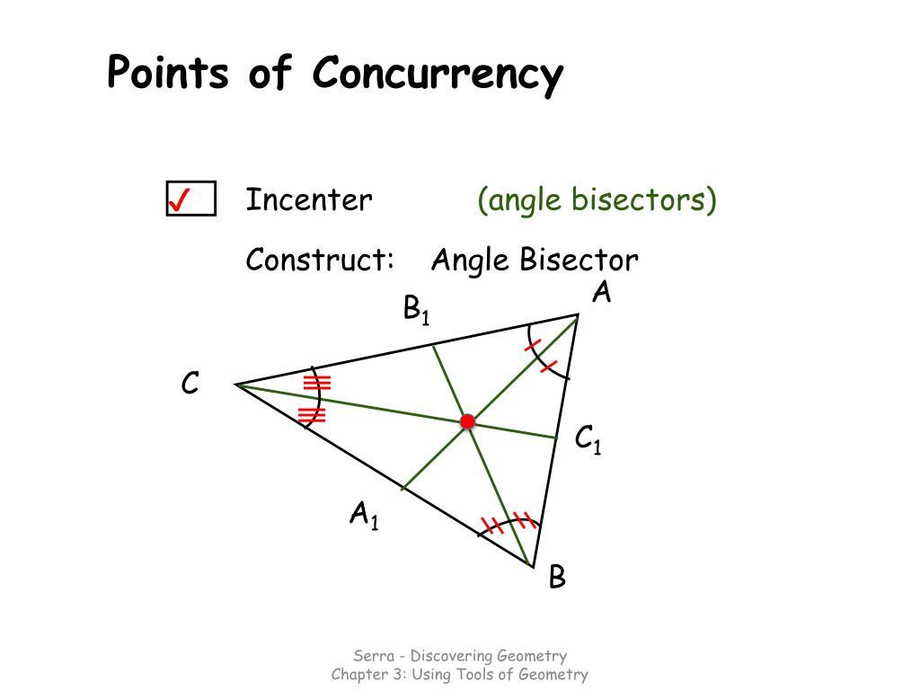

Perpendicular Bisector and Angle Bisector
# Source: AI Source: Provided by: [Data Path: Persons Table -> ID Column: 1, Name_En Column: Motasem Essam] -> From: [ChatGPT] on [7/25/2026]
Different types of loci can also intersect.
For example:
$$L_{1}=\text{perpendicular bisector of }AB$$
and
$$L_{2}=\text{angle bisector of }∠C.$$
Their intersection is a point satisfying both conditions:
$$PA=PB$$
and
$$d\left(P , CA\right)=d\left(P , CB\right).$$
Therefore:
$$\boxed{P∈L_{1}∩L_{2}}$$
means both geometric relationships hold simultaneously.

Fixed-Distance Circle and Perpendicular Bisector
# Source: AI Source: Provided by: [Data Path: Persons Table -> ID Column: 1, Name_En Column: Motasem Essam] -> From: [ChatGPT] on [7/25/2026]
Suppose:
$$PA=r$$
and
$$PB=PC.$$
The first condition produces a circle centered at $A$.
The second condition produces the perpendicular bisector of $BC$.
Therefore, the required points are:
$$\boxed{\text{Circle centered at }A∩\text{Perpendicular bisector of }BC}$$
There may be zero, one, or two solutions.

Fixed-Angle Locus and Another Locus
# Source: AI Source: Provided by: [Data Path: Persons Table -> ID Column: 1, Name_En Column: Motasem Essam] -> From: [ChatGPT] on [7/25/2026]
Suppose $A$and $B$are fixed and
$$∠APB=θ.$$
This produces a circular-arc locus.
Now impose another condition:
$$PC=r.$$
This produces another circle.
The required points are the intersections between the fixed-angle circular arc and the second circle.
Thus:
$$\boxed{\text{Fixed-Angle Locus}∩\text{Circle Locus}}$$
gives the points satisfying both conditions.

Intersection of Three or More Loci
# Source: AI Source: Provided by: [Data Path: Persons Table -> ID Column: 1, Name_En Column: Motasem Essam] -> From: [ChatGPT] on [7/25/2026]
The idea extends to any number of conditions.
If
$$L_{1},L_{2},L_{3}$$
are three loci, then
$$\boxed{L_{1}∩L_{2}∩L_{3}}$$
contains points satisfying all three conditions.
For example:
$$PA=PB, \\ PB=PC, \\ PC=PD.$$
A point satisfying all of them must satisfy:
$$\boxed{PA=PB=PC=PD}.$$
The intersection may contain:
- no points,
- one point,
- several points,
- or infinitely many points,
depending on the geometry.

Intersection of Loci as a Geometric Construction Method
# Source: AI Source: Provided by: [Data Path: Persons Table -> ID Column: 1, Name_En Column: Motasem Essam] -> From: [ChatGPT] on [7/25/2026]
Many straightedge-and-compass constructions are fundamentally intersections of loci.
For example, to construct a triangle from three side lengths:
Given
$$AB=c, \\ AC=b,$$
and
$$BC=a,$$
we can:
- Draw $AB$.
- Construct the circle centered at $A$with radius $b$.
- Construct the circle centered at $B$with radius $a$.
- Their intersection gives possible locations of $C$.
Thus:
$$\boxed{C=\text{Circle}\left(A , b\right)∩\text{Circle}\left(B , a\right)}$$
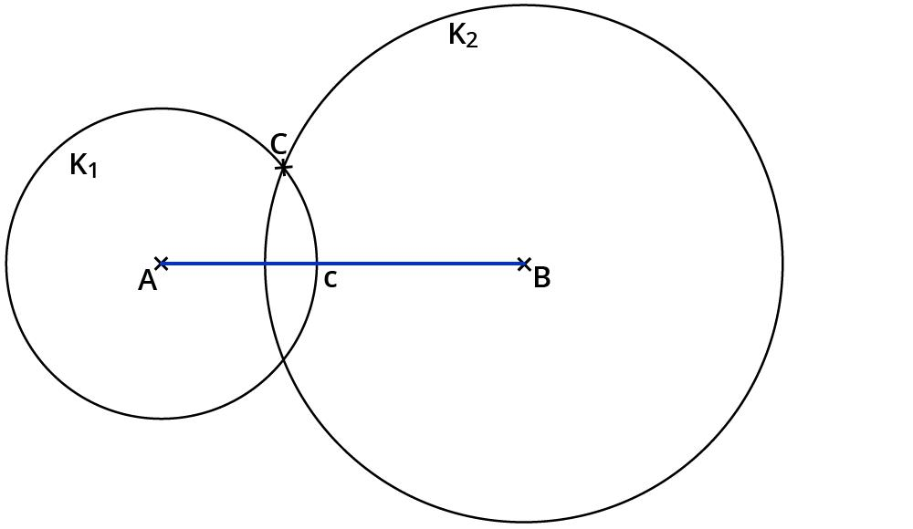
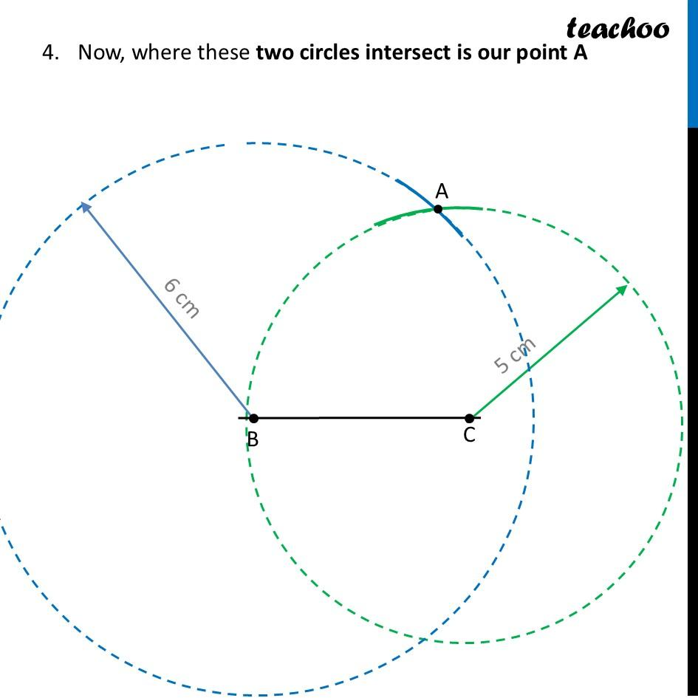
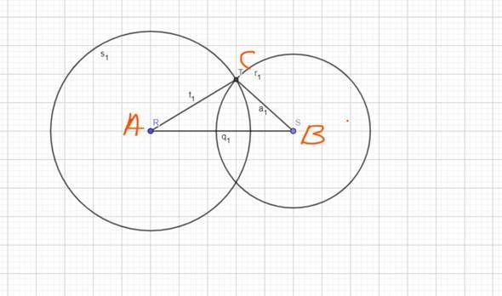
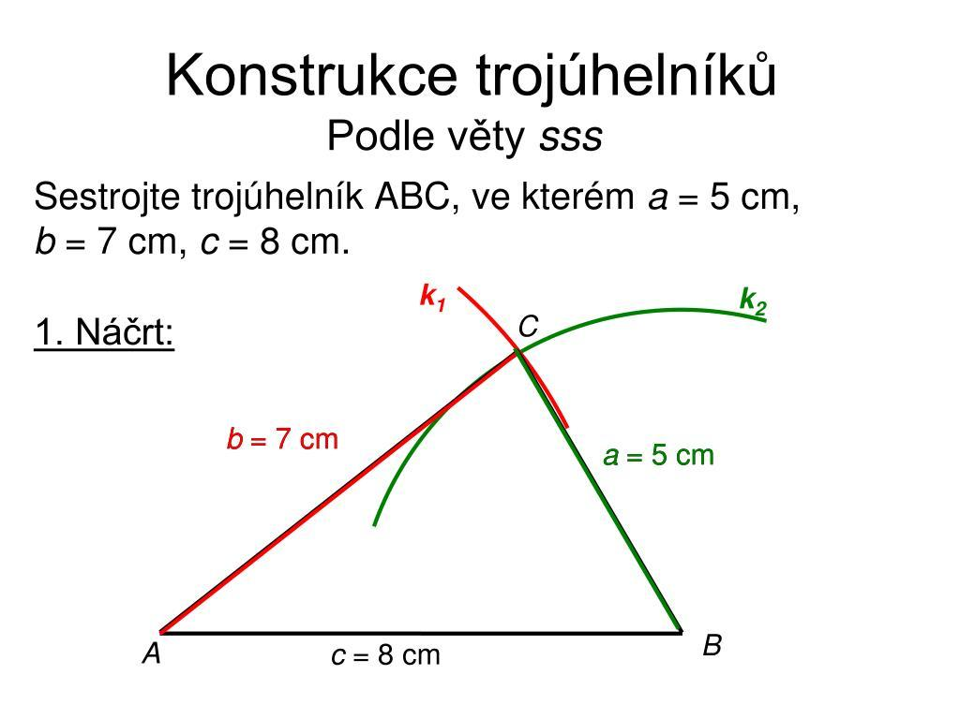
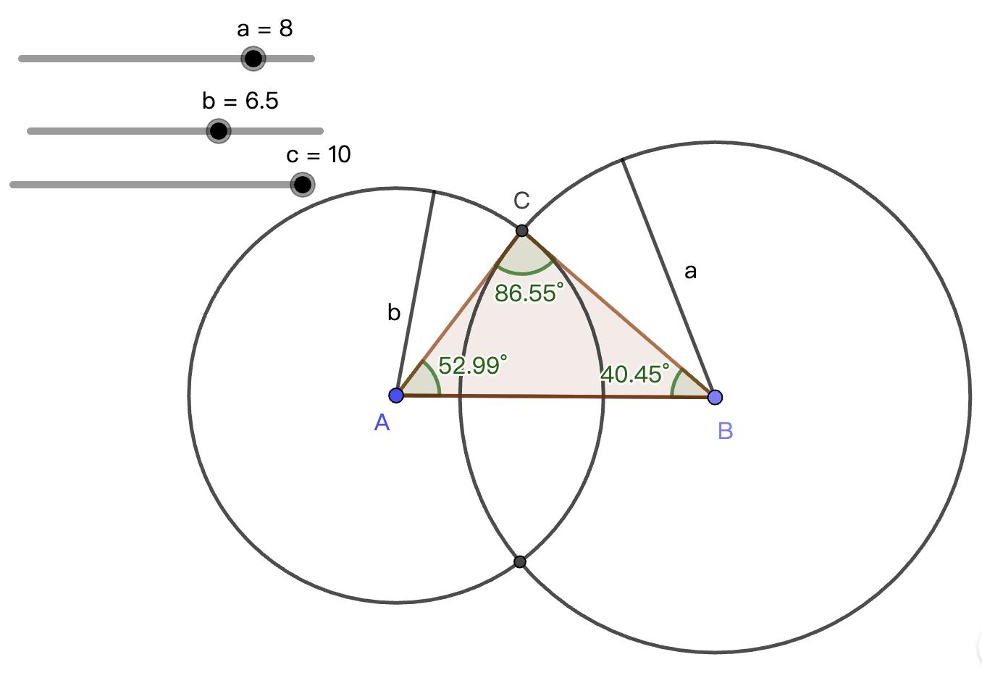
This is one of the clearest examples of the intersection-of-loci principle.

Intersection of Loci and Geometric Constraints
# Source: AI Source: Provided by: [Data Path: Persons Table -> ID Column: 1, Name_En Column: Motasem Essam] -> From: [ChatGPT] on [7/25/2026]
A geometric problem can often be rewritten as:
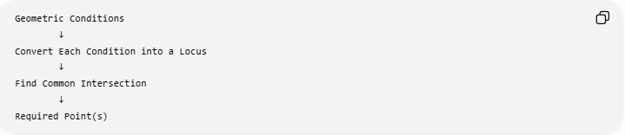
Geometric Conditions
↓
Convert Each Condition into a Locus
↓
Find Common Intersection
↓
Required Point(s)
For example:
Find a point $P$that is 4 units from $A$and equally distant from $B$and $C$.
Convert each condition:
$$PA=4$$
gives a circle.
$$PB=PC$$
gives the perpendicular bisector of $BC$.
Therefore:
$$\boxed{P=\text{Circle}\left(A , 4\right)∩\text{Perpendicular Bisector of }BC}$$

Number of Solutions
# Source: AI Source: Provided by: [Data Path: Persons Table -> ID Column: 1, Name_En Column: Motasem Essam] -> From: [ChatGPT] on [7/25/2026]
The number of intersection points corresponds to the number of possible solutions.
No intersection
$$\boxed{0\text{ solutions}}$$
Tangency
$$\boxed{1\text{ solution}}$$
Two intersections
$$\boxed{2\text{ solutions}}$$
Multiple loci
Additional conditions can reduce the number of solutions.
For example:
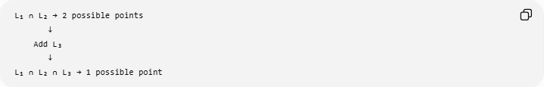
L₁ ∩ L₂ → 2 possible points
↓
Add L₃
↓
L₁ ∩ L₂ ∩ L₃ → 1 possible point
This is common in geometric construction problems.

Example with Coordinates
# Source: AI Source: Provided by: [Data Path: Persons Table -> ID Column: 1, Name_En Column: Motasem Essam] -> From: [ChatGPT] on [7/25/2026]
Suppose $P=\left(x , y\right)$must satisfy:
$$PA=5$$
where
$$A=\left(0 , 0\right),$$
and
$$PB=5$$
where
$$B=\left(6 , 0\right).$$
The two loci are:
$$x^{2}+y^{2}=25$$
and
$${\left(x-6\right)}^{2}+y^{2}=25.$$
Subtracting:
$$x^{2}-{\left(x-6\right)}^{2}=0.$$
Expanding:
$$x^{2}-\left(x^{2}-12x+36\right)=0 \\ 12x-36=0 \\ x=3.$$
Substitute into the first circle:
$$3^{2}+y^{2}=25 \\ y^{2}=16.$$
Therefore:
$$y=±4.$$
The two intersection points are:
$$\boxed{P_{1}=\left(3 , 4\right)}$$
and
$$\boxed{P_{2}=\left(3 , -4\right)}.$$
So the two circles have two common locus points.

Important Distinction: Intersection vs Union
# Source: AI Source: Provided by: [Data Path: Persons Table -> ID Column: 1, Name_En Column: Motasem Essam] -> From: [ChatGPT] on [7/25/2026]
The intersection requires a point to satisfy all conditions:
$$\boxed{L_{1}∩L_{2}}$$
means AND.
The union requires a point to belong to at least one locus:
$$\boxed{L_{1}∪L_{2}}$$
means OR.
Example
If
$$L_{1}: PA=3$$
and
$$L_{2}: PB=4,$$
then:
$$L_{1}∩L_{2}$$
means
$$PA=3 \text{and} PB=4.$$
But
$$L_{1}∪L_{2}$$
means
$$PA=3 \text{or} PB=4.$$
This distinction is essential.

Intersection of Loci and Triangle Centers
# Source: AI Source: Provided by: [Data Path: Persons Table -> ID Column: 1, Name_En Column: Motasem Essam] -> From: [ChatGPT] on [7/25/2026]
Several important triangle centers can be understood through intersecting loci.
Circumcenter
Intersection of perpendicular-bisector loci:
$$\boxed{OA=OB, OA=OC}$$
Incenter
Intersection of angle-bisector loci:
$$\boxed{d\left(I , AB\right)=d\left(I , AC\right)}$$
and
$$\boxed{d\left(I , AB\right)=d\left(I , BC\right)}$$
Other centers
Some other geometric centers can similarly be characterized by intersections of geometric conditions, although their locus descriptions may involve different constructions.

Common Types of Locus Intersections
# Source: AI Source: Provided by: [Data Path: Persons Table -> ID Column: 1, Name_En Column: Motasem Essam] -> From: [ChatGPT] on [7/25/2026]
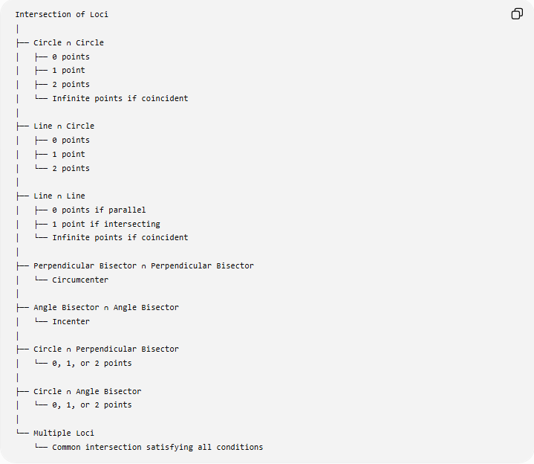
Intersection of Loci
│
├── Circle ∩ Circle
│ ├── 0 points
│ ├── 1 point
│ ├── 2 points
│ └── Infinite points if coincident
│
├── Line ∩ Circle
│ ├── 0 points
│ ├── 1 point
│ └── 2 points
│
├── Line ∩ Line
│ ├── 0 points if parallel
│ ├── 1 point if intersecting
│ └── Infinite points if coincident
│
├── Perpendicular Bisector ∩ Perpendicular Bisector
│ └── Circumcenter
│
├── Angle Bisector ∩ Angle Bisector
│ └── Incenter
│
├── Circle ∩ Perpendicular Bisector
│ └── 0, 1, or 2 points
│
├── Circle ∩ Angle Bisector
│ └── 0, 1, or 2 points
│
└── Multiple Loci
└── Common intersection satisfying all conditions

General Locus-Intersection Method
# Source: AI Source: Provided by: [Data Path: Persons Table -> ID Column: 1, Name_En Column: Motasem Essam] -> From: [ChatGPT] on [7/25/2026]
When solving a locus problem:
Step 1 — Identify the conditions
Determine exactly what the unknown point $P$must satisfy.
Step 2 — Convert each condition into a locus
For example:
$$PA=r$$
becomes a circle.
$$PA=PB$$
becomes a perpendicular bisector.
$$d\left(P , l_{1}\right)=d\left(P , l_{2}\right)$$
becomes an angle-bisector locus.
Step 3 — Intersect the loci
Find:
$$\boxed{L_{1}∩L_{2}}$$
or
$$\boxed{L_{1}∩L_{2}∩L_{3}}.$$
Step 4 — Check every candidate
Every intersection point must satisfy all original conditions.
This final check is important because restrictions may eliminate some intersection points.

Classification
# Source: AI Source: Provided by: [Data Path: Persons Table -> ID Column: 1, Name_En Column: Motasem Essam] -> From: [ChatGPT] on [7/25/2026]
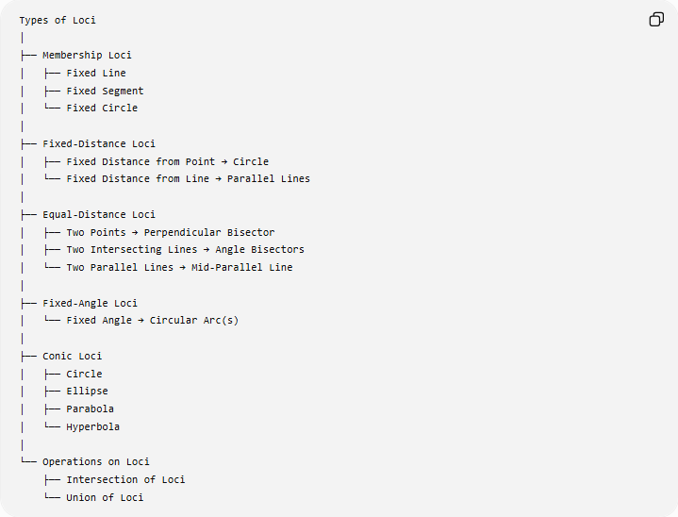
Types of Loci
│
├── Membership Loci
│ ├── Fixed Line
│ ├── Fixed Segment
│ └── Fixed Circle
│
├── Fixed-Distance Loci
│ ├── Fixed Distance from Point → Circle
│ └── Fixed Distance from Line → Parallel Lines
│
├── Equal-Distance Loci
│ ├── Two Points → Perpendicular Bisector
│ ├── Two Intersecting Lines → Angle Bisectors
│ └── Two Parallel Lines → Mid-Parallel Line
│
├── Fixed-Angle Loci
│ └── Fixed Angle → Circular Arc(s)
│
├── Conic Loci
│ ├── Circle
│ ├── Ellipse
│ ├── Parabola
│ └── Hyperbola
│
└── Operations on Loci
├── Intersection of Loci
└── Union of Loci

Key Formulas
# Source: AI Source: Provided by: [Data Path: Persons Table -> ID Column: 1, Name_En Column: Motasem Essam] -> From: [ChatGPT] on [7/25/2026]
Intersection of two loci
$$\boxed{L_{1}∩L_{2}}$$
Intersection of three loci
$$\boxed{L_{1}∩L_{2}∩L_{3}}$$
Membership condition
$$\boxed{P∈L_{1}∩L_{2} ⟺ P∈L_{1}\text{ and }P∈L_{2}}$$
Circle locus
$$\boxed{PA=r}$$
Perpendicular-bisector locus
$$\boxed{PA=PB}$$
Angle-bisector locus
$$\boxed{d\left(P , l_{1}\right)=d\left(P , l_{2}\right)}$$
Fixed-angle locus
$$\boxed{∠APB=θ}$$

Classification Summary
# Source: AI Source: Provided by: [Data Path: Persons Table -> ID Column: 1, Name_En Column: Motasem Essam] -> From: [ChatGPT] on [7/25/2026]
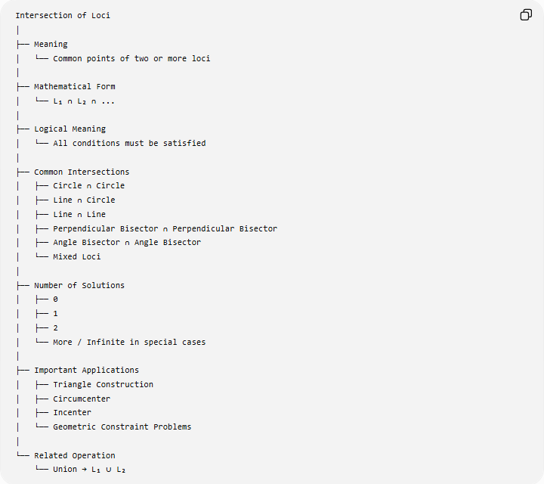
Intersection of Loci
│
├── Meaning
│ └── Common points of two or more loci
│
├── Mathematical Form
│ └── L₁ ∩ L₂ ∩ ...
│
├── Logical Meaning
│ └── All conditions must be satisfied
│
├── Common Intersections
│ ├── Circle ∩ Circle
│ ├── Line ∩ Circle
│ ├── Line ∩ Line
│ ├── Perpendicular Bisector ∩ Perpendicular Bisector
│ ├── Angle Bisector ∩ Angle Bisector
│ └── Mixed Loci
│
├── Number of Solutions
│ ├── 0
│ ├── 1
│ ├── 2
│ └── More / Infinite in special cases
│
├── Important Applications
│ ├── Triangle Construction
│ ├── Circumcenter
│ ├── Incenter
│ └── Geometric Constraint Problems
│
└── Related Operation
└── Union → L₁ ∪ L₂

Key Points
# Source: AI Source: Provided by: [Data Path: Persons Table -> ID Column: 1, Name_En Column: Motasem Essam] -> From: [ChatGPT] on [7/25/2026]
- An intersection of loci consists of points satisfying multiple locus conditions simultaneously.
- Its mathematical notation is
$$\boxed{L_{1}∩L_{2}}.$$
- Intersection means AND, not OR.
- Two circles can intersect at $0$, $1$, or $2$points, with coincident circles as a special infinite-intersection case.
- A line and circle can intersect at $0$, $1$, or $2$points.
- The circumcenter is an intersection of perpendicular-bisector loci.
- The incenter is an intersection of angle-bisector loci.
- Many geometric constructions can be understood as finding the intersection of appropriate loci.
- Adding more locus conditions generally reduces the set of possible points.

Conclusion
# Source: AI Source: Provided by: [Data Path: Persons Table -> ID Column: 1, Name_En Column: Motasem Essam] -> From: [ChatGPT] on [7/25/2026]
The Intersection of Loci is a fundamental method for solving geometric constraint problems. Each condition defines a locus, and the required point or points are found where those loci overlap:
$$\boxed{\text{Condition 1}→L_{1}} \\ \boxed{\text{Condition 2}→L_{2}} \\ \boxed{\text{Required Points}=L_{1}∩L_{2}}$$
More generally,
$$\boxed{\text{Required Points}=L_{1}∩L_{2}∩⋯∩L_{n}}$$
Thus, the central principle is:
$$\boxed{\text{Multiple Geometric Conditions}→\text{Multiple Loci}→\text{Common Intersection}→\text{Solution(s)}}$$

